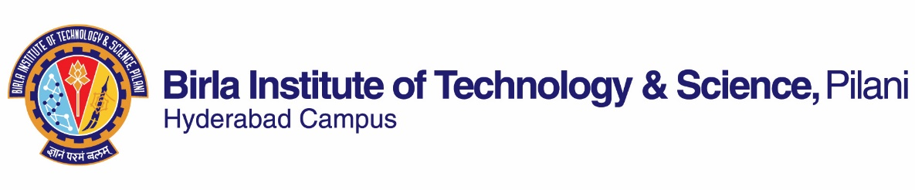

**~~FIRST~~/ SECOND SEMESTER 2019-2020**

# Course Handout Part II

Date: 06-01-2020

In addition to part-I (General Handout for all courses appended to the time table) this portion gives further specific details regarding the course.

## **Course No.**: ME F420

## **Course Title**: Power Plant Engineering

## **Instructor-in-charge**: MORAPAKALA SRINIVAS

**Scope and Objective of the Course:**

This course has been designed to make the students familiar with the power plant engineering and technology. It deals with the thermal, hydro, and nuclear power plants. The course also discusses non-conventional power generation. The economic analysis, economic loading, load curve analysis will also be discussed.

**Textbook:**

1. **P. K. Nag,** Power Plant Engineering, Tata McGraw-Hill Publishing Company Ltd, Third Ed., 2008.

**Reference books**

1. Bernhardt G.A. Strotzki and William A. Vopat, “Power Station Engineering and Economy”, Tata McGraw-Hill Publishing Company Ltd, New Delhi, 1960.
2. M.M. EI-Wakil, “Powerplant Technology”, McGraw-Hill International Edition, 1984.

**Course Plan:**

| **Lecture Nos.** | **Learning Objectives** | **Topics to be covered** | **Chapter in the Text Book** |
| --- | --- | --- | --- |
| 1 | Introduction and power scenario of India | Introduction | 1.5 |
| 2-5 | Steam power cycles, Efficiency improvement of stem power cycles | Analysis of Steam Cycles | 2.1 – 2.17 |
| 6-8 | Working of fluid power cycles, binary vapor cycles, GT-ST power plant | Combined Cycle Power Generation | 3.1 – 3.6 |
| 9-12 | Important fuels, Stoichiometry, Control of excess air, Draught systems, essentials of combustion equipment | Fuels, Combustion and Draught systems | 4.1 – 4.2, 4.11, 4.14, 5 |
| 13-16 | Types of boilers, Efficiency improvement of boilers, Pollution control of boilers, Feed water treatment | Steam Generators | 6.1 – 6.6, 6.8 – 6.18 |
| 17-19 | Nozzles | Energy conversion aspects of Steam nozzles | 7.1 – 7.2 |
| 20-22 | Steam Turbine | Energy conversion aspects of Steam Turbines | 7.1 – 7.2 |
| 23-26 | Condensers, Cooling towers | Condenser, Feed Water, Circulating Water System | 8.1 – 8.6 |
| 27-30 | Basics, Nuclear reactors | Nuclear Power Plant | 9.15 – 9.22 |
| 31-33 | Optimization of hydro-thermal mix, Hydro turbines, Cavitation, Performance of turbines | Hydroelectric Power Plant | 10.1 – 10.3, 10.10 – 10.20, 10.24 – 10.25 |
| 34-36 | Types of plants, Efficiency evaluation | Diesel engine, Gas Turbine Power Plants | 11.1 – 11.4, 11.6 – 11.9 |
| 37-38 | Load curve, Availability of power, Power plant economics, Electricity pricing | Economics of power generation | 1.1 – 1.2 |
| 39-40 | Renewable energy sources, Solar and Wind based power generation, Biomass, Geothermal & other sources for power generation | Non-Conventional Power Generation | 14.1 – 14.10 |

**Evaluation Scheme:**

|  |  |  |  |  |
| --- | --- | --- | --- | --- |
| **Component** | **Duration** | **Weightage (%)** | **Date & Time** | **Nature of Component** |
| Mid semester test | 90 min | 20 | 4/3 3.30 - 5.00 PM | Closed book |
| Surprise tests# | 10 min each | 10 | Surprise in nature | Open book |
| Written reports on assignments/projects@ | Take home | 15 | Will be informed | Open book |
| Seminar/presentations@ | Will be informed | 15 | Will be informed | Open book |
| Comprehensive Examination | 3 hours | 40 | 08/05 AN | Closed book |

# On the whole there would be 3 surprise tests of which 2 best would be considered for 10% weightage. These surprise tests would be conducted during regular class work sessions.

@ On the whole there would be two assignments/projects, the topics of which would be given to the students. The reports are to be submitted in hand written format. The seminars/presentations shall be on assignments/projects. Other details would be communicated separately.

**Chamber Consultation Hour:** To be announced in the class room.

**Notices:** All notices concerning this course shall be displayed on the CMS (the Institute’s web based course management system). Besides this, students are advised to visit regularly CMS for latest updates.

**Make-up Policy:** Make-up shall be given only to the genuine cases with prior confirmation. Request for the make-up tests, duly signed by the students, should reach the under signed well before the scheduled test.

**Academic Honesty and Integrity Policy:** Academic honesty and integrity are to be maintained by all the students throughout the semester and no type of academic dishonesty is acceptable.

**Instructor-in-Charge**

**ME F420**